# CS 255 System Design Document

## UML Diagrams

### UML Use Case Diagram

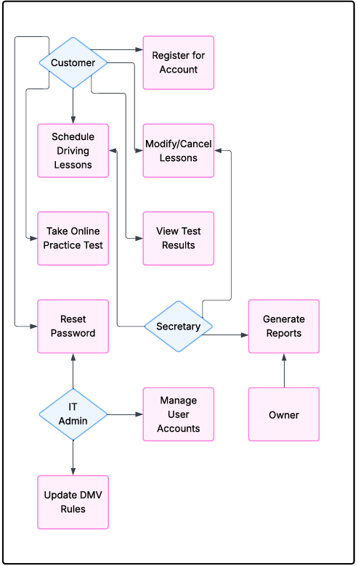

### UML Activity Diagrams

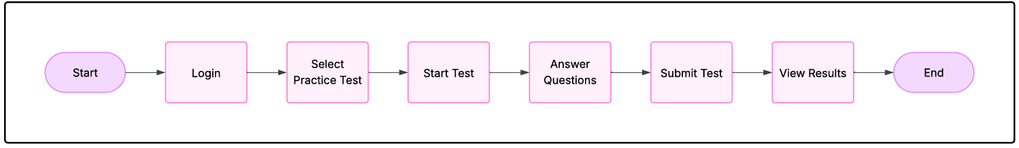

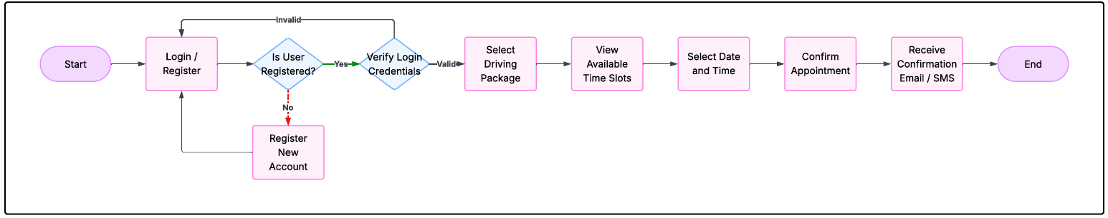

### UML Sequence Diagram

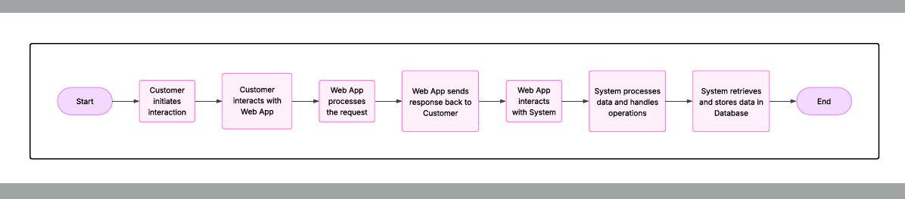

### UML Class Diagram

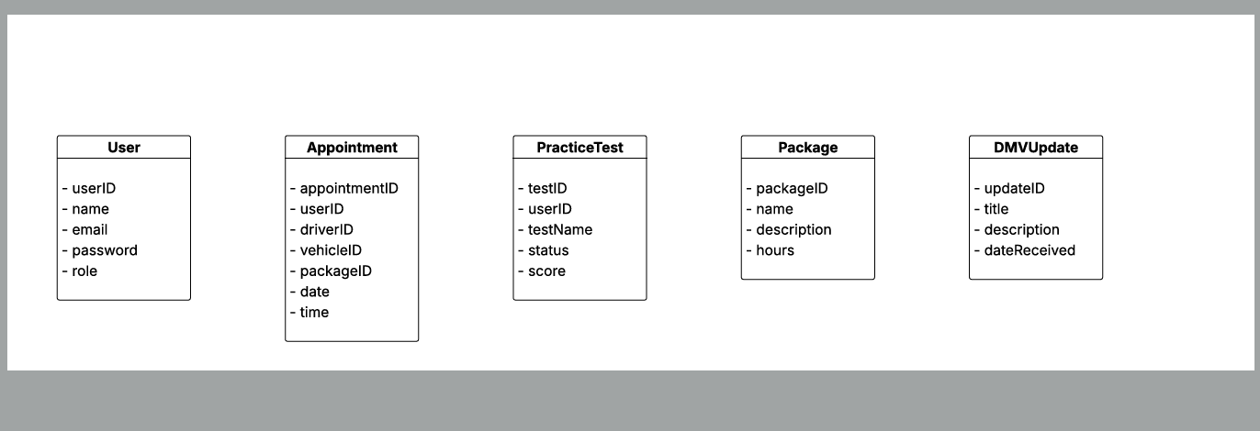

## Technical Requirements

**Hardware Requirements**

* The DriverPass system will be hosted in a cloud environment (such as AWS, Azure, or Google Cloud) to provide reliability, scalability, and accessibility.
* End users will require standard computing devices, such as desktops, laptops, tablets, or smartphones with internet connectivity.
* No specialized hardware will be necessary for customers or staff beyond basic access devices.

**Software Requirements**

* The system will be web-based and accessible through common modern web browsers (Google Chrome, Mozilla Firefox, Safari, and Microsoft Edge).
* The backend of the system will utilize a secure web server and application framework capable of handling business logic, user authentication, scheduling, and reporting.
* A relational database management system (such as MySQL or PostgreSQL) will be used to store user accounts, appointments, practice test data, and system logs.

**Network and Security Requirements**

* A persistent internet connection is required for end users to access the system and for administrators to manage it remotely.
* All data exchanges between users and the server will be encrypted using SSL/TLS protocols to ensure data privacy and integrity.
* User authentication will include secure login credentials, role-based access control, account lockouts after repeated failed login attempts, and password reset functionality via verified email links.

**Administrative and Infrastructure Requirements**

* The system will include administrative portals for IT administrators and the owner to manage users, disable packages, and generate business reports.
* Regular backups of system data will be conducted through the cloud platform to ensure business continuity and disaster recovery.
* System maintenance and software updates (such as security patches and DMV content updates) will be scheduled regularly to ensure the system remains current and secure.

**Limitations and Assumptions**

* The system will depend on accurate and timely DMV updates for the practice test materials and policy changes.
* The initial deployment will support expected user loads but may require scaling adjustments if the user base grows rapidly.